Styles, Henry Gordon
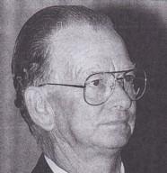
Joined Forests Department staff on 24.11.1954. At Ludlow training school 1952-53. Appointed forest guard 1954. Worked in Busselton area in 1960s, Promoted to Forester 1.5.1964. At Ludlow in 1966/67. District Forester at Dwellingup in 1970s. In Manjimup-Pemberton area in 1970s-90s. Senior Fire Operations Officer, when retired December 1991, after almost 44 years service. Awarded Australian Fire service Medal. A fire lookout tower in the Blackwood valley is named after him.

